CS 255 System Design Document Template

UML Diagrams

UML Use Case Diagram
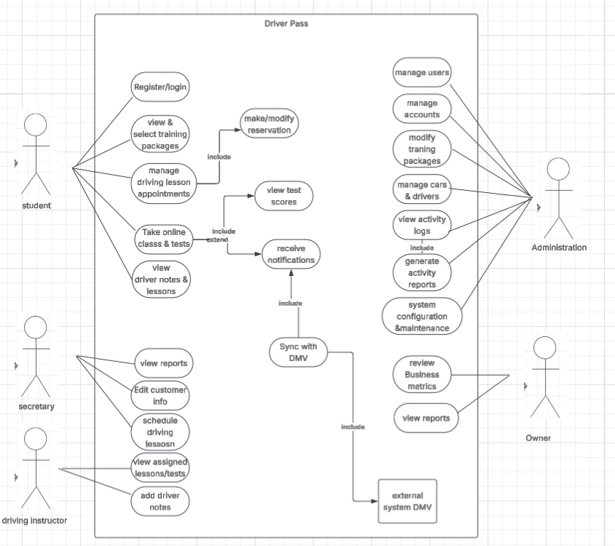

UML Activity Diagrams

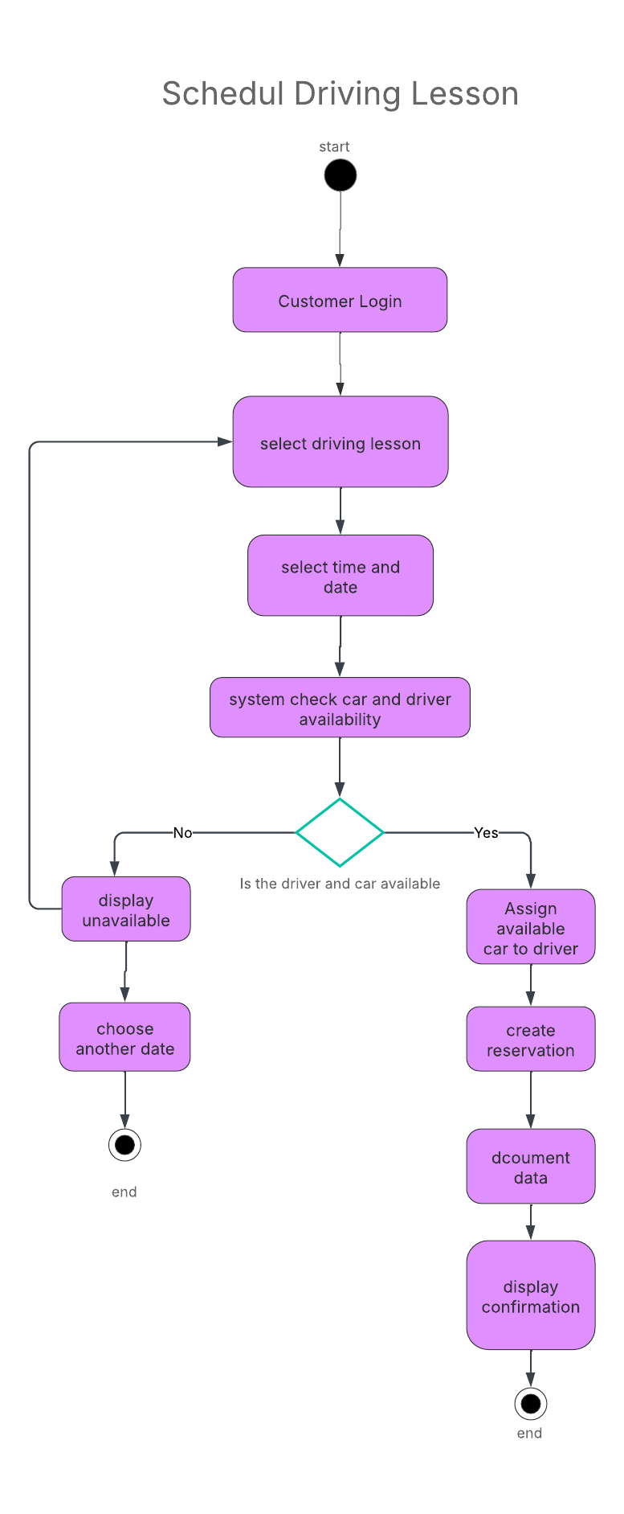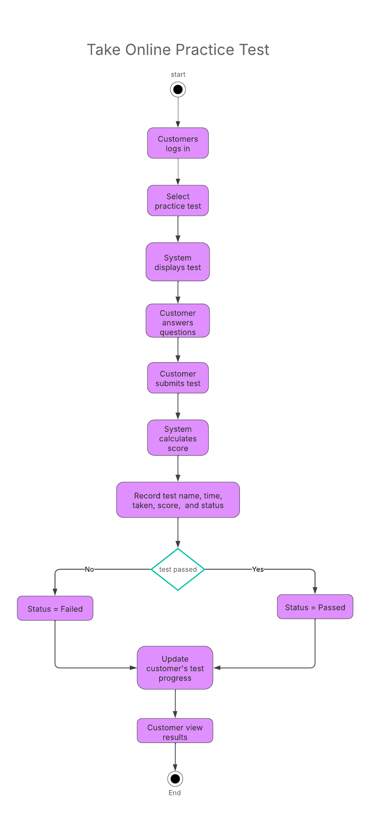

UML Sequence Diagram
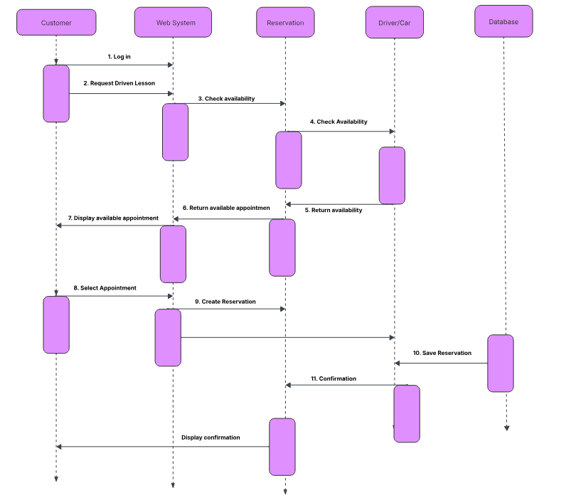

UML Class Diagram

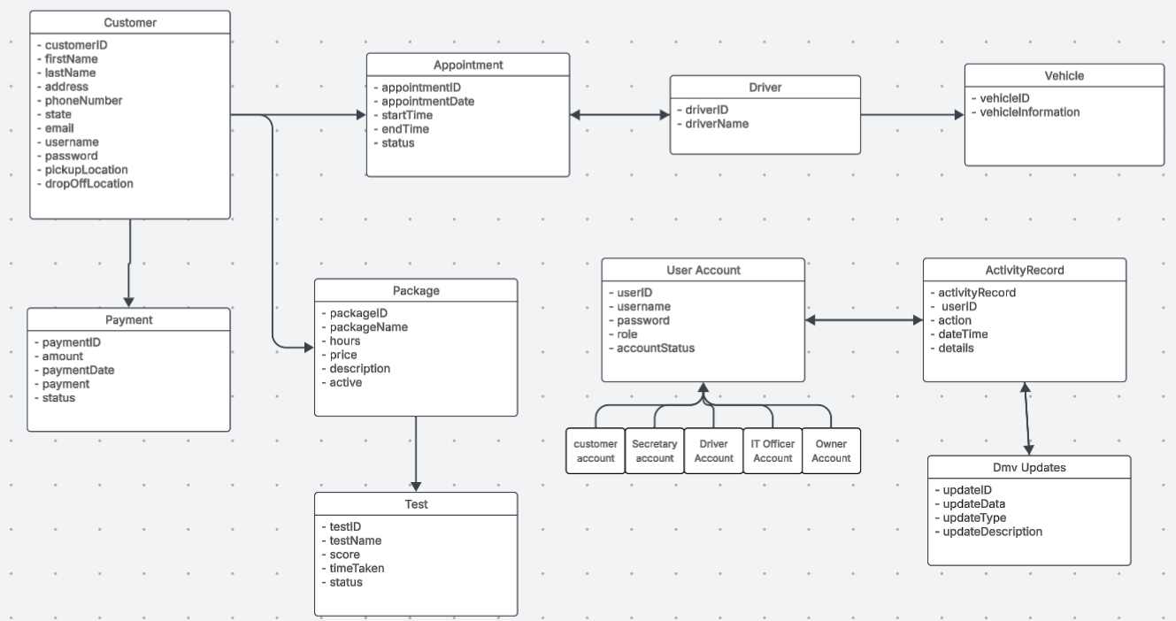

Technical Requirements
Hardware: The system must support computers and mobile devices because DriverPass wants customers and employees to access the system from any computer or mobile device.
Software: The system needs a web-based application, customer and employee account management, appointment scheduling, online classes and practice tests, reporting, security controls, and database functionality.
Tools: The development team will use tools such as a web-development environment, database software, testing tools, and Lucidchart for system design. The client also needs the ability to download reports and information for use in programs such as Excel.
Infrastructure: The system should be hosted in the cloud so DriverPass does not have to manage its own servers, backups, or security infrastructure. It should provide secure user authentication, role based access, password resets, account blocking, and activity tracking.

